=
EUDIGITOOL.V3.0

User’s Manual

September 2021

July 2022

EUDIGITOOL
USER MANUAL V3.0
Context 3
What is the EUDIGITOOL? 3
System hierarchy 4
User roles in the system 7
How to access the EUDIGITOOL? 8
How to become a user? 9
User dashboard 10
Approval procedure 12
Communication materials 14
Creating and uploading communication materials 15
Commenting on the communication materials 17
Editing the created files 17
Insert comments in the documents 17
Replacing PDF communication materials 18
Publishing 18
My materials 19
New project (for Admins) 19
Assigning users (for Admins) 19
My projects 20
Project profile 20
Project/ programme results 22
Events 23
Beneficiary 24
Posts 26
Videos 26
Photos 28
Translation of content 31
Automatic generation of project info sheet 32
How to search for a project in the EUDIGITOOL 32
EUDIGITOOL Support Portal 33
Questions and answers 36

Context

With the EU’s reinforced focus on delivering effective communication in the Eastern partner countries (EaP countries), the number of campaigns and the volume of communication materials are constantly being drastically multiplied. This creates a huge demand for up-to-date information and success stories showcasing the EU-EaP cooperation and partnership in action, including precise information about the EU-funded projects/programmes, their objectives, expected and achieved results, activities, as well as their positive impact on people's lives, presented to the public along with catchy visuals.
Before there were no systems in place which would collate and consolidate project information from the communication perspective, namely communication materials, photos, videos, contacts of projects and beneficiaries, etc. The data was often hidden deep in the projects’ dossiers, in the annexes of the reports or even only available in the private archives of Project Managers and contractors. In addition to that, there was no other corporate memory system in place.
Hence, the main objective became to create a sustainable unified online digital tool- the EUDIGITOOL that would enable the European Commission, specifically the DG NEAR, EEAS, the EU Delegations to the EaP countries, as well as other EU institutions and agencies to generate, manage, publish and archive project information, outputs, outcomes and overall impact more efficiently and effectively for communication purposes.
The goal has been achieved and currently the EUDIGITOOL is fully functional and has taken the communication of the EU-funded projects to a new level.

What is the EUDIGITOOL?

The EUDIGITOOL, fully integrated online communication platform, with its regional and country branches brings together the EU-funded projects that run in the Eastern Partnership (EaP) countries and across the region.

The projects’ information, communication materials, photos and videos are being published from the EUDIGITOOL onto the EU4Country.eu and euneighbourseast.eu websites with a single click in real-time, ensuring higher visibility for the EU-funded projects.
- It is an interactive online tool for managing and improving the EU-funded projects’ communication.
- It is a platform built around user/project-driven data input ensuring that projects’ information is always up-to-date.
- It brings together key information, results, events, communication materials, photos, videos, posts and main contacts.
- It simplifies and clarifies interaction between projects and DG NEAR, as well as the EU Delegations to the EaP countries.
- It brings the review and approval processes for communication-related content online with simple Google Docs integration, enabling multiple users to edit the same document simultaneously and see version history, as well as replacing the good-old emailing of documents, eliminating all the hassle with different versions, software compatibility and lack of mobile support.
- It includes an Events Calendar which allows better communication planning and a long-term view.
- It serves as a comprehensive archive for projects’ communication materials in the long run.
- It provides a possibility to publish the EU-funded projects’ static information, communication materials, website posts and visuals (after the final approval) on the public frontends of the EUDIGITOOL (EU4Country.eu and euneighbiurseast.eu websites).

System hierarchy

The main entity in the EUDIGITOOL is the Project. A Project can also be part of an Umbrella Programme.

Each Project can have an unlimited number of sub-entities: Events and Beneficiaries.

Each Project has its individual content page (project profile) with its communication materials, as well as Photo and Video Galleries.

Check out below the structure of the system.
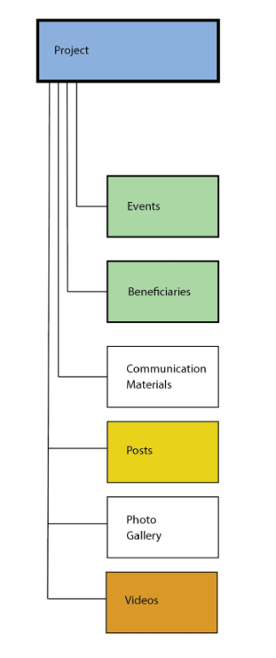
The EUDIGITOOL contains multiple interfaces. It is a unified system, based on the central database/platform, which is also synchronised with the EUDIGITOOL-integrated euneighbourseast.eu and EU4country.eu websites, which enables the publication of content on those websites.

Check out the Chart below.
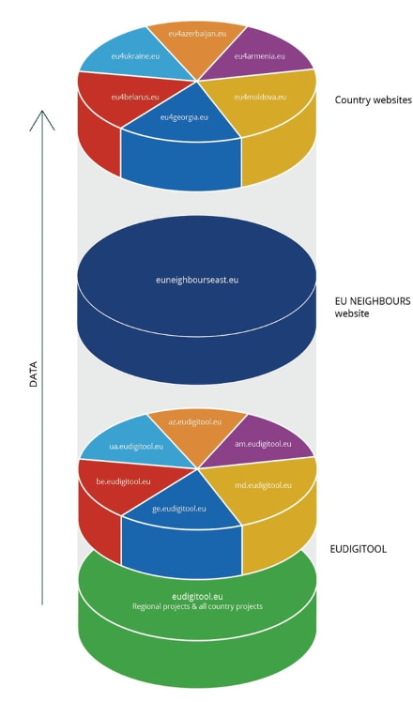

User roles in the EUDIGITOOL

PROJECT USER is responsible for the input of the content of his/her project, as well as the content in the sub-entities for Events and Beneficiaries related to the project. The Project User has full responsibility for keeping the information about the project up-to-date and uploading communication materials, as well as photos, videos, etc.

REVIEWER is responsible for the quality assurance of the project information, communication and promotional materials.
(Usually, the Reviewer works for the main communication contractor of the respective EU Delegation).

EU PROJECT MANAGER is responsible for approving the generic information about the project managed by him/her, as well as all project-related Events, Beneficiaries’ information, Communication materials, Audio-visual and editorial content, etc.

ADMIN is responsible for completing the approval processes by publishing the approved information and content, creating new project entries and adding users to the system, managing all entries’ data, as well as for ensuring the overall quality of the system.
SUPERADMIN has the rights and responsibilities similar to the ADMIN, and in addition could create sensitive projects in the system which could be accessed only by authorised users.

OBSERVER role in the system allows the user to see the data/content in the system that has status ‘published’, however has no editing rights (i.e. can’t enter or delete data, etc).

Only ADMINs and SUPERADMINs can create new projects, new users and assign other users to projects, as well as change users’ role and grant them (or take away) editing rights.

Chart of user rights

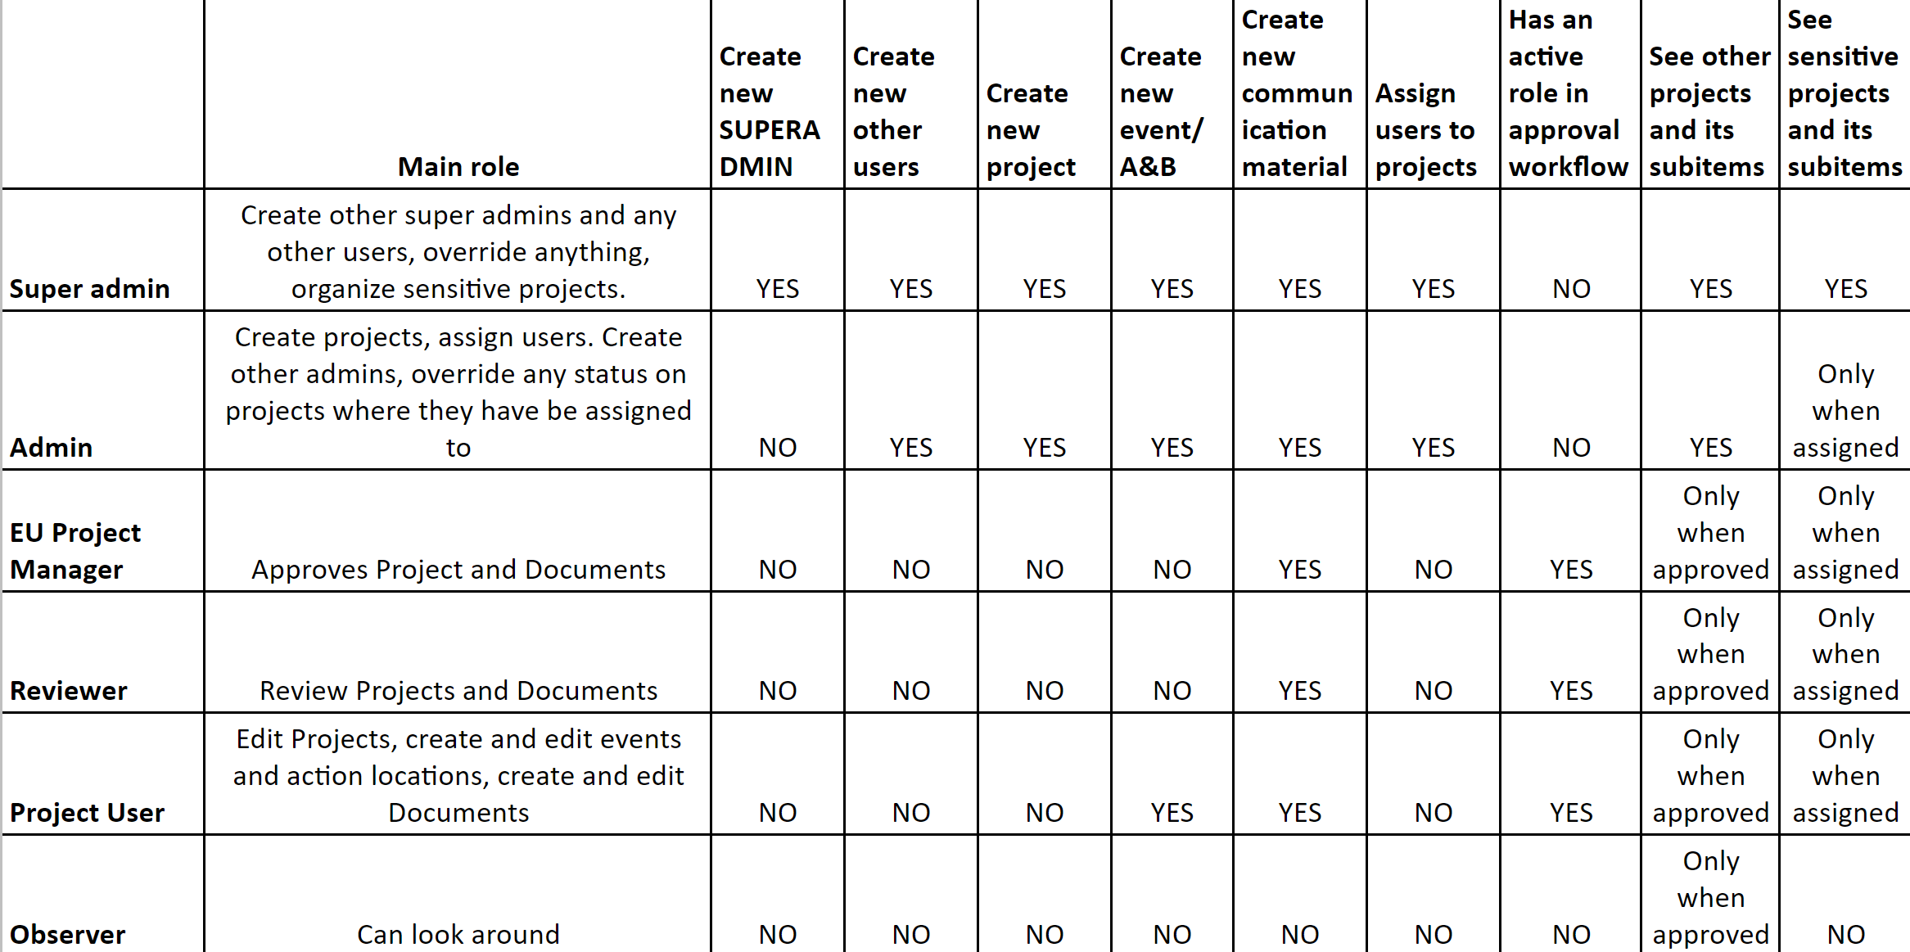

How to access the EUDIGITOOL?

Please use your web browser to access the EUDIGITOOL:

- am.eudigitool.eu for Armenia
- az.eudigitool.eu for Azerbaijan
- by.eudigitool.eu for Belarus
- ge.eudigitool.eu for Georgia
- md.eudigitool.eu for Moldova
- ua.eudigitool.eu for Ukraine

- www.eudigitool.eu for the Central interface or managing regional projects/programmes, as well as browsing regional and country specific projects/programmes all from the same environment.

Google Chrome and Mozilla Firefox are the recommended browsers for using the EUDIGITOOL, nevertheless Microsoft Edge and Safari would work in most cases.
NB! Internet Explorer and other legacy browsers are not supported.

The EUDIGITOOL is also compatible with mobile browser and all the actions can be performed also via your mobile phone.
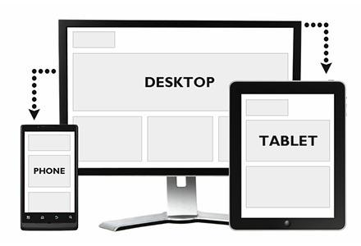

How to become a user?
In order to become a user of the EUDIGITOOL, your e-mail address has to be registered manually in the system by the ADMIN or SUPERADMIN. For bilateral projects/programmes this is usually the Communication Coordinator of the EU Delegation or the Delegation’s communication contractor.

For regional projects it is the EUDIGITOOL Focal Point from the ‘EU NEIGHBOURS east’ programme, who is also entitled to create user profiles in all country tools.

As soon as the ADMIN/SUPERADMIN creates your user profile, you will receive an e-mail invitation from the EUDIGITOOL. Click the link and it will take you to the page where you can set your password (see below). Invitation link could be used only once and won’t be accessible the second time.
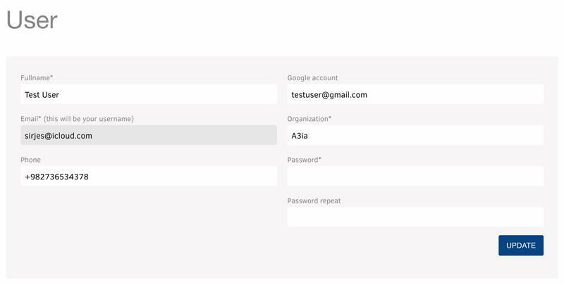

Please type your password in the ‘Password’ and ‘Password repeat’ fields and click Update to set your password and save user details. You can also change the information encoded in other fields, beside the password field, if necessary.

To access and change your user details later, go to the Users drop-down menu and select My User Profile.

User dashboard

When you log in and click the EUDIGITOOL logo (top left corner of your screen), you will see your dashboard under the Events’ Calendar. The dashboard contains your pending tasks’ list including all items that require your action. All the projects, related events and documents that need your action will appear there.

The users' main goal is to keep the dashboard clean.

The Events’ calendar will give you an overview of the upcoming events. You can also connect the EUDIGITOOL calendar with your personal Google calendar. This will ensure live updates in your personal calendar.

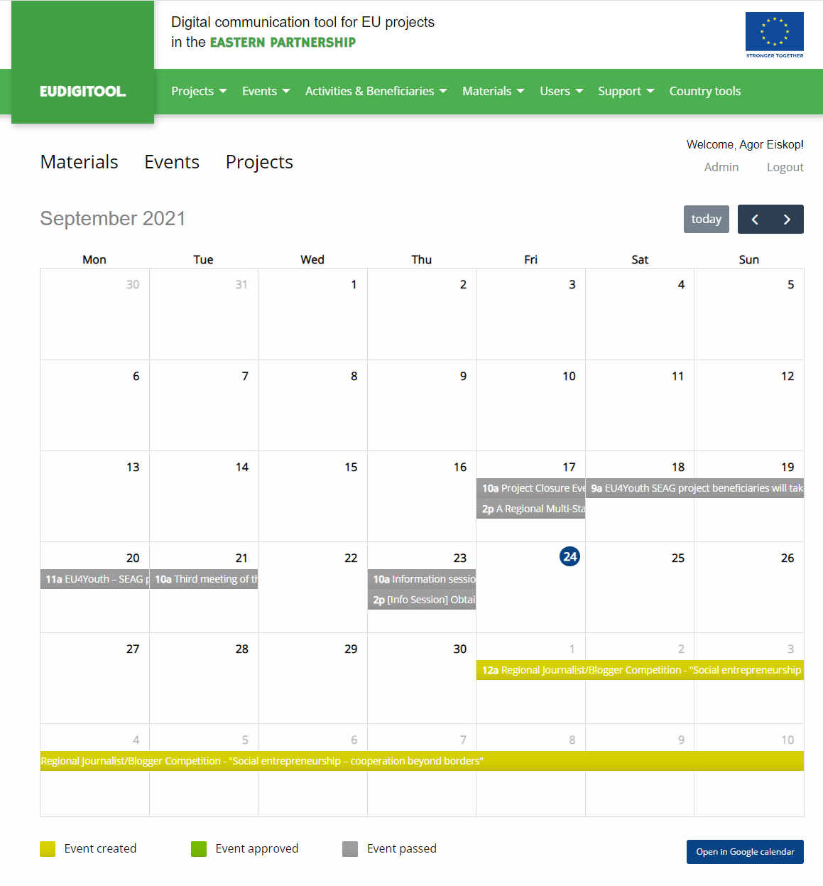

Approval procedure

All the content in the EUDIGITOOL must be validated through the quality assurance procedure via multiple user roles before being published. This process is fully automated. When there is a new task, it will appear on each user’s dashboard and the respective user will get instantly notified by e-mail. There are also “opt-in/opt-out” daily and weekly notification e-mails to track tasks on dashboard, if there are any. In ‘my user profile’ you may select the option you are most comfortable with.

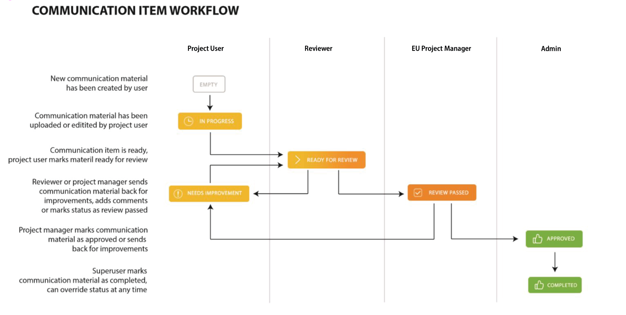

Content quality-assurance workflow applies to:

- Projects – the main generic information about the project
- Events
- Beneficiaries
- Communication materials
- Videos
- Posts

The procedure consists of 6 steps:

- In Progress/Created: After creating a project profile, event, beneficiary information, post or uploading communication materials and videos, the status is by default set as ‘In Progress’ or ‘Created’.

- Ready for Review: Once you have finished editing the content, please change the status to ‘Ready for Review’.

- Review Passed: The Reviewer(s) assigned to your project will then review the project/ event information, beneficiary information or the uploaded communication materials and videos from the linguistic, communication and visibility perspective. If it is fine, the Reviewer will change the status to ‘Review Passed’.

- Needs Improvement: In case your project profile, event or beneficiary information, post, as well as communication materials and videos need improvements, you will get them back to your Dashboard with the status ‘Needs Improvement’, along with remarks from the Reviewers inserted in the relevant section for comments. Once you do the necessary improvements change the status back to ‘Ready for Review’.

- Approved: After your project profile, event , post or beneficiary information, as well as communication materials and videos pass the review stage, they reach the level of your EU Project Manager, who has to give the approval by changing the status to ‘Approved’.

In case additional improvements are required, you will receive them back with ‘Needs Improvement’ status and have to follow the procedure described above.

- Published: The last step is for the ADMIN/SUPERADMIN to complete the process by changing the status to ‘Published’. The green tab ‘Published’ means that you are free to release the communication items to the general public. Once the status ‘Published’ is granted by the ADMIN/SUPERADMIN, the content will be visible in the EUDIGITOOL to all users (unless it is a sensitive project and only Users with special status could see it) as well as it will automatically be displayed on the euneighbourseast.eu and the respective EU4Country.eu websites.

You will also receive an e-mail notification every time a new item lands on your Dashboard, and requires your action, as well as once the communication materials/events/etc. are approved or the process is complete. You will also get daily and weekly updates (depending on the option you have chosen in your user profile) regarding your dashboard, giving you an overview if there is any action required from your side.

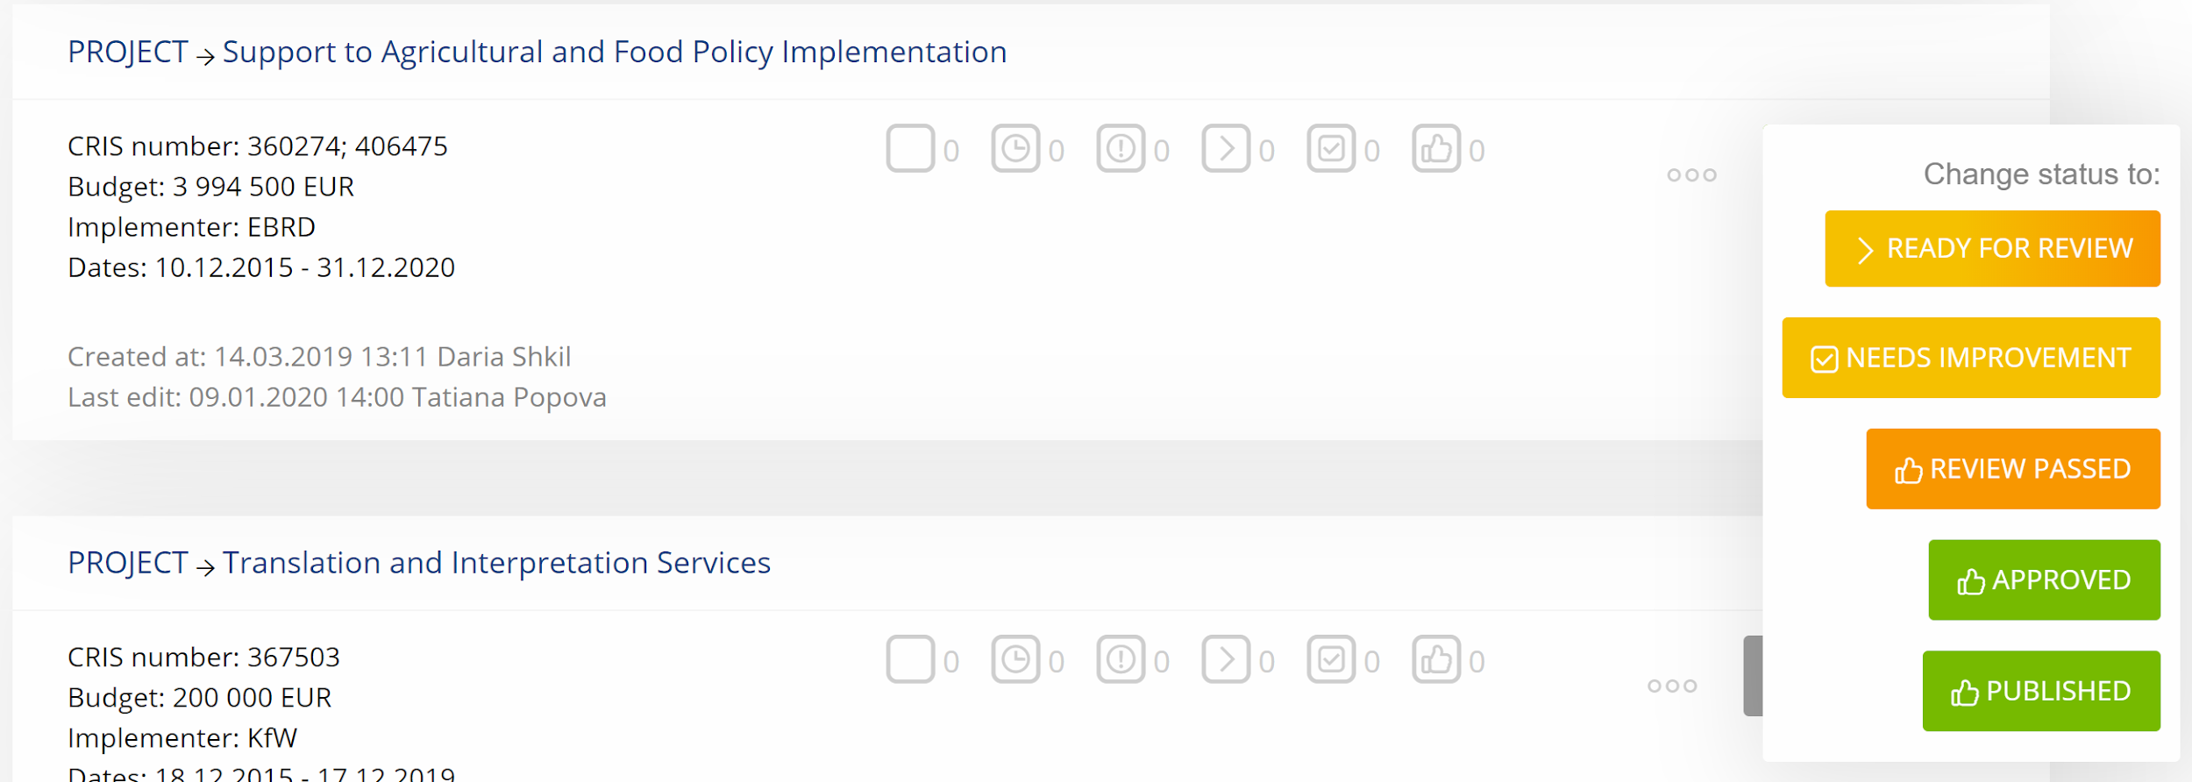

NB! ADMINs can override any status of any content at any stage.

Communication materials

This category refers to any communication material produced within the framework of your EU-funded project, including a press release, factsheet, leaflet, campaign outline, promotional item and not only which will be approved by your EU Project Manager. If your project is ongoing, please also add the materials already produced in the past for archiving purposes and notify the respective ADMIN that the communication item does not require passing a new approval workflow and could be published.

The EUDIGITOOL has integration with Google Docs as an editor and Google Drive as a content aggregator.

To start working with communication materials, please click the ‘Add new’ button, write the name of the file (please write the full name of the file - i.e: if you are adding a press release, please indicate the name of the event or topic). After you name the file and click add, it will show up in the Project’s Communication materials section, click the ‘Create’ button and choose the format of the file you are going to upload or work with from the drop-down menu.

Creating and Uploading Communication Materials
There are six options for creating/uploading a new document:

- Load default document template.
- Create a blank document: Creates a Google Docs document.
NB! THIS IS THE MOST COMMON OPTION TO START WITH
- Upload and convert a Word document - upload Word documents, which will be converted to Google Docs documents (15MB max).
- Upload PDF: upload a *pdf file. You can still use online commenting and other features (15MB max).
- Upload any other file, for example *txt, *ai, *psd, etc. (15MB max).
- Provide URL: PLEASE USE HERE A LINK TO YOUTUBE, VIMEO, ETC.

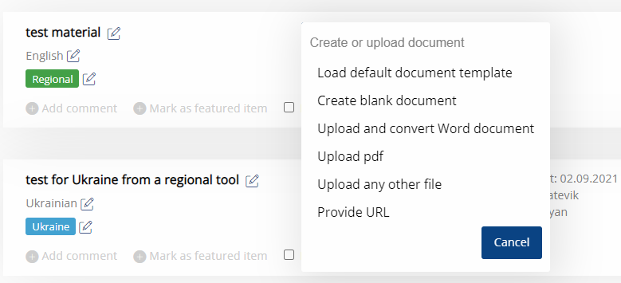
In the Regional branch of the EUDIGITOOL local Reviewers are assigned to each project profile to ensure that the project information, communication materials and visuals are quality-assured from the EU communication and visibility perspective in all the EaP languages, as well as in English and Russian.

In order to ensure that your communication materials land on the relevant Reviewer’s dashboard for review, please select the language in which the content is produced. The system will automatically send the notification to the relevant Reviewer(s) based on your language choice. The choice of multiple languages is possible.

In the Regional branch of the EUDIGITOOL, apart from the EU Project Managers from the European Commission, Project/Sector Managers of the EU Delegations in the EaP countries where the project is being implemented in are assigned as well to approve country-specific communication materials produced by regional projects/programmes.

For communication materials of regional nature select ‘Regional’ to ensure that they are approved by your European Commission’s Project Manager. For country-specific communication materials please select the relevant country to direct the approval to the respective Project/Sector Manager in the EU Delegation.

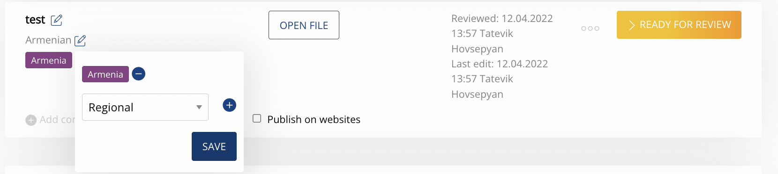

When selecting the country and language from the respective dropdown lists under the title click ‘+’ then ‘SAVE’ buttons respectively.

After being published in the system, all the communication materials which have a tick the box ‘Publish on websites’ will be displayed on your project page of the euneighbourseast.eu and EU4Country.eu websites.

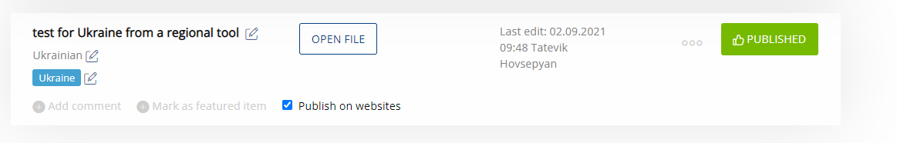

The project profiles are being published on the aforementioned websites by default as soon as they have the status ‘Published’ in the system.

NB: Currently the following EU4Country.eu websites are public:

- EU4Armenia.eu
- EU4Azerbaijan.eu
- EU4Georgia.eu
- EU4Moldova.eu

Commenting on Communication materials
The field ‘Add comment’ is intended for making comments regarding communication materials during the approval process.
Editing the created files
All the created documents are saved on Google Drive and are automatically editable with anyone who has a link to the document – ‘Open’ the file to edit it.
Inserting Comments directly into Documents
All the uploaded documents, including the PDFs could have comments on the Google Documents view.

- Highlight the text, images, cells, or slides you would like to comment on.
- Add a comment, in the toolbar, click ‘Add comment’.
- Type your comment.
- Click ‘Comment’.

We recommend you use your google account for commenting, so all members of the workflow process may see each other and can communicate efficiently.

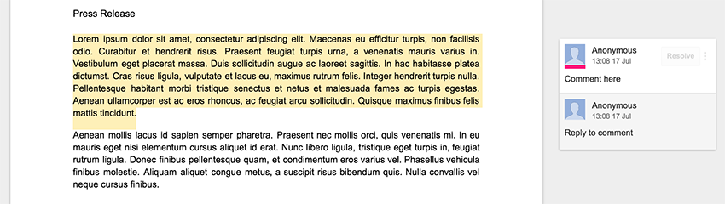

All changes in the approval process which require action will appear on your Dashboard.

Replacing PDF communication materials
If you have to revise your PDF communication material after receiving it back with comments, you may already simply replace the draft file with the revised one by keeping the approval history and all the comments made in that process.
The below presented image demonstrates how the file replacement should be done for the communication materials in PDF format.
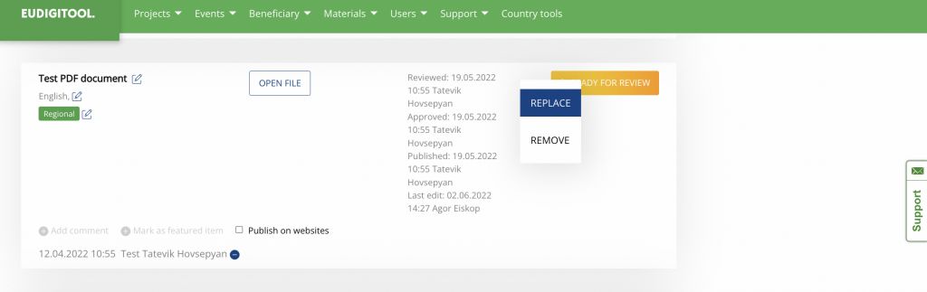

Publishing
After the approval of the communication material by the EU Project Manager, the ADMINs will mark it as ‘Published’. That means that the material is ready to go out to the public. Material is now visible for all the EUDIGITOOL users. The editing properties have been removed from the file; you can see it only by the lock icon next to file open tab.

The approved communication materials will be published on your project page on the euneighbourseast.eu and EU4Country.eu websites, if the Admin deems it suitable for publishing. It will be published in a printable file format and presented on your project page in a list of attachments which can be downloaded by visitors.

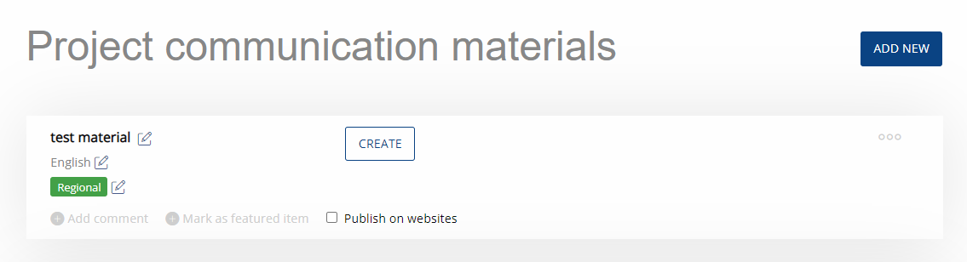

My Materials

‘My Materials’ section contains all the communication materials created and approved during the implementation of your project, as well as the lifecycle of all Events or Beneficiaries.

Creating new projects and assigning users (for Admins and SuperAdmins)

New project profiles can be created by ADMINs/SUPERADMINs only. Each Project profile must have at least one Project User, Reviewer and EU Project Manager assigned to the project for the approval workflow purposes. The ADMIN/SUPERADMIN can access all projects by clicking the ‘All Projects’ menu item.

The assigned users can access the Project’s sub-items: Events and Beneficiary sections.

The project pages and communication materials are visible for other users who are not assigned to your project profile only when they have the status ‘Published’. The workflow through which the item went and the comments will not be visible to the other users in the system or to the general public on the websites.
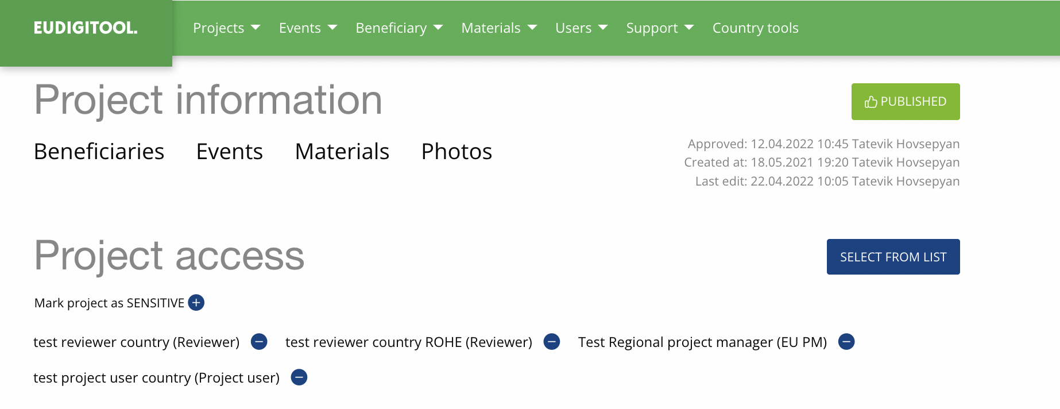

My projects
To find projects which are assigned to you, go to the ‘Projects’ menu (at the top) and select ‘My projects’ in the sub-menu.

If you have projects assigned to you, they will appear like this:

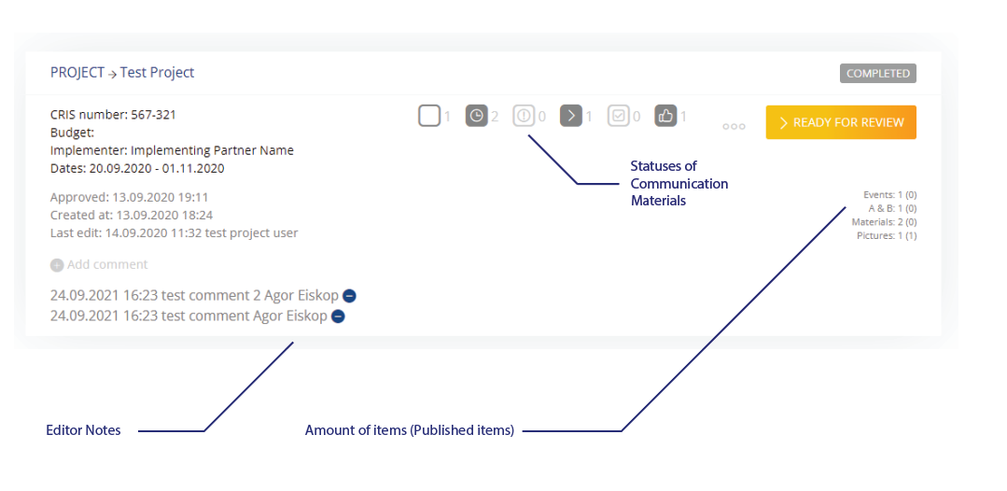

Project profile
Project profiles are also created by ADMINs/SUPERADMINs. Some project profiles are already filled out, finalised and translated in local languages, so please do not update any field unless it is an absolute necessity. If necessary, please coordinate with your EU Project Manager and/or the SUPERADMIN before changing anything in the project information and ensure the translations in the local languages are revised accordingly. If the status of the project profile is ‘Approved’, it means that it was quality checked by the Reviewer and also confirmed by your EU Project Manager.

The mandatory fields that have to be filled out are maked with asterisk *:

NB! It is highly recommended to fill out all the fields in your project page.

The title of the project in English should be already filled out, please write the title of your project in the local language (s).

The description of your project: The description must provide the key information about the project. Note that only the first eleven lines will be included in the automatically generated factsheet. It is important to ensure that the syntax is correct, the narrative is clear and reads well, so that the content is comprehensive to the general public. Do not automatically copy and paste from the ToR. Please also fill out the description in the local language(s). This content will be generated by the system for publication on the websites interlined with the EUDIGITOOL.

Tagwords: Insert tagwords separated by comma. They will facilitate the project search in the system. Tagwords can be a keyword from the title, the sector, the topic, etc.

Start date/End date: Select the start and end dates of the project from the calendar.

Regional/Local Umbrella: Select the regional/local umbrella from the list, if relevant. Click + to add more. +’.

Region: Pick a region (or several) from the list. You can also choose ‘All country’ if the project covers the whole country.

Location: This is a location (or several) where the project is being implemented or the project implementing organisation’s Head Office is located. Enter the address and select the exact location from the list. If the address doesn't appear automatically, drop the pin manually on the location in the map. Click + to add more.

Website: If the project has its own website, please enter the link of this website, if it doesn't, you can put the link of the project page of the implementing partner’s official website. If the latter doesn't exist either, leave this field empty.

Social Media Account: If the project has its own social media accounts, please provide the link to the accounts. Additional notes (in the EaP country tools): This section is intended for comments, notes and suggestions, mainly from the EU Delegation.

Detailed Description of the Project (in the EaP country tools): Please add here information about all components of your project and its activities in a user-friendly language in English and in the local language.

EU Project Manager’s Contact Information: Please indicate the name and contact information of the EU Project Manager.

Team Leader’s Contact Information: Please indicate the name and contact information of the Project Team Leader.

Communication Contact Person’s Contact Information: Please indicate the name and contact information of the project’s communication contact person. This should be a person who will be in charge of editing the project page.

Project/Programme Results

Specific Objective: Indicate the overall and specific objectives of the programme/project. Two introductory sentences with the overall objective and up to 5 bullet points with the specific objectives. Keep the length of the text within 220 words (1558 characters with spaces).

Expected Results: Indicate the overall and specific objectives of the programme/project in the local language. Two introductory sentences with the overall objective and up to 5 bullet points with the specific objectives. Keep the length of the text within 220 words (1558 characters with spaces).

End Summary: Provide the short summary of the results that have been already achieved at the end of the project/programme.

Stakeholders’ Quotes: Add quotes from the direct beneficiaries of the programme/project, indicating how they benefited from the EU's support and what impact it has/had on their daily life. Please ensure you obtain their consent first. You are responsible for ensuring GDPR compliance and any relevant legal requirements under your contract with the EU.

Events

Entries must be created for all the visibility events that you plan to organise within the framework of the Project/Programme.

To add an event, please use the button ‘Add new’ next to the Event’s section in the Project profile, fill out the respective fields and upload the event-related communication materials.

The Events have to pass the standard approval workflow described above. Apart from getting approval of the event and its communication materials, this feature also aims to ensure alignment with the priorities and planned schedule of communication events/activities in DG NEAR and EU Delegations.

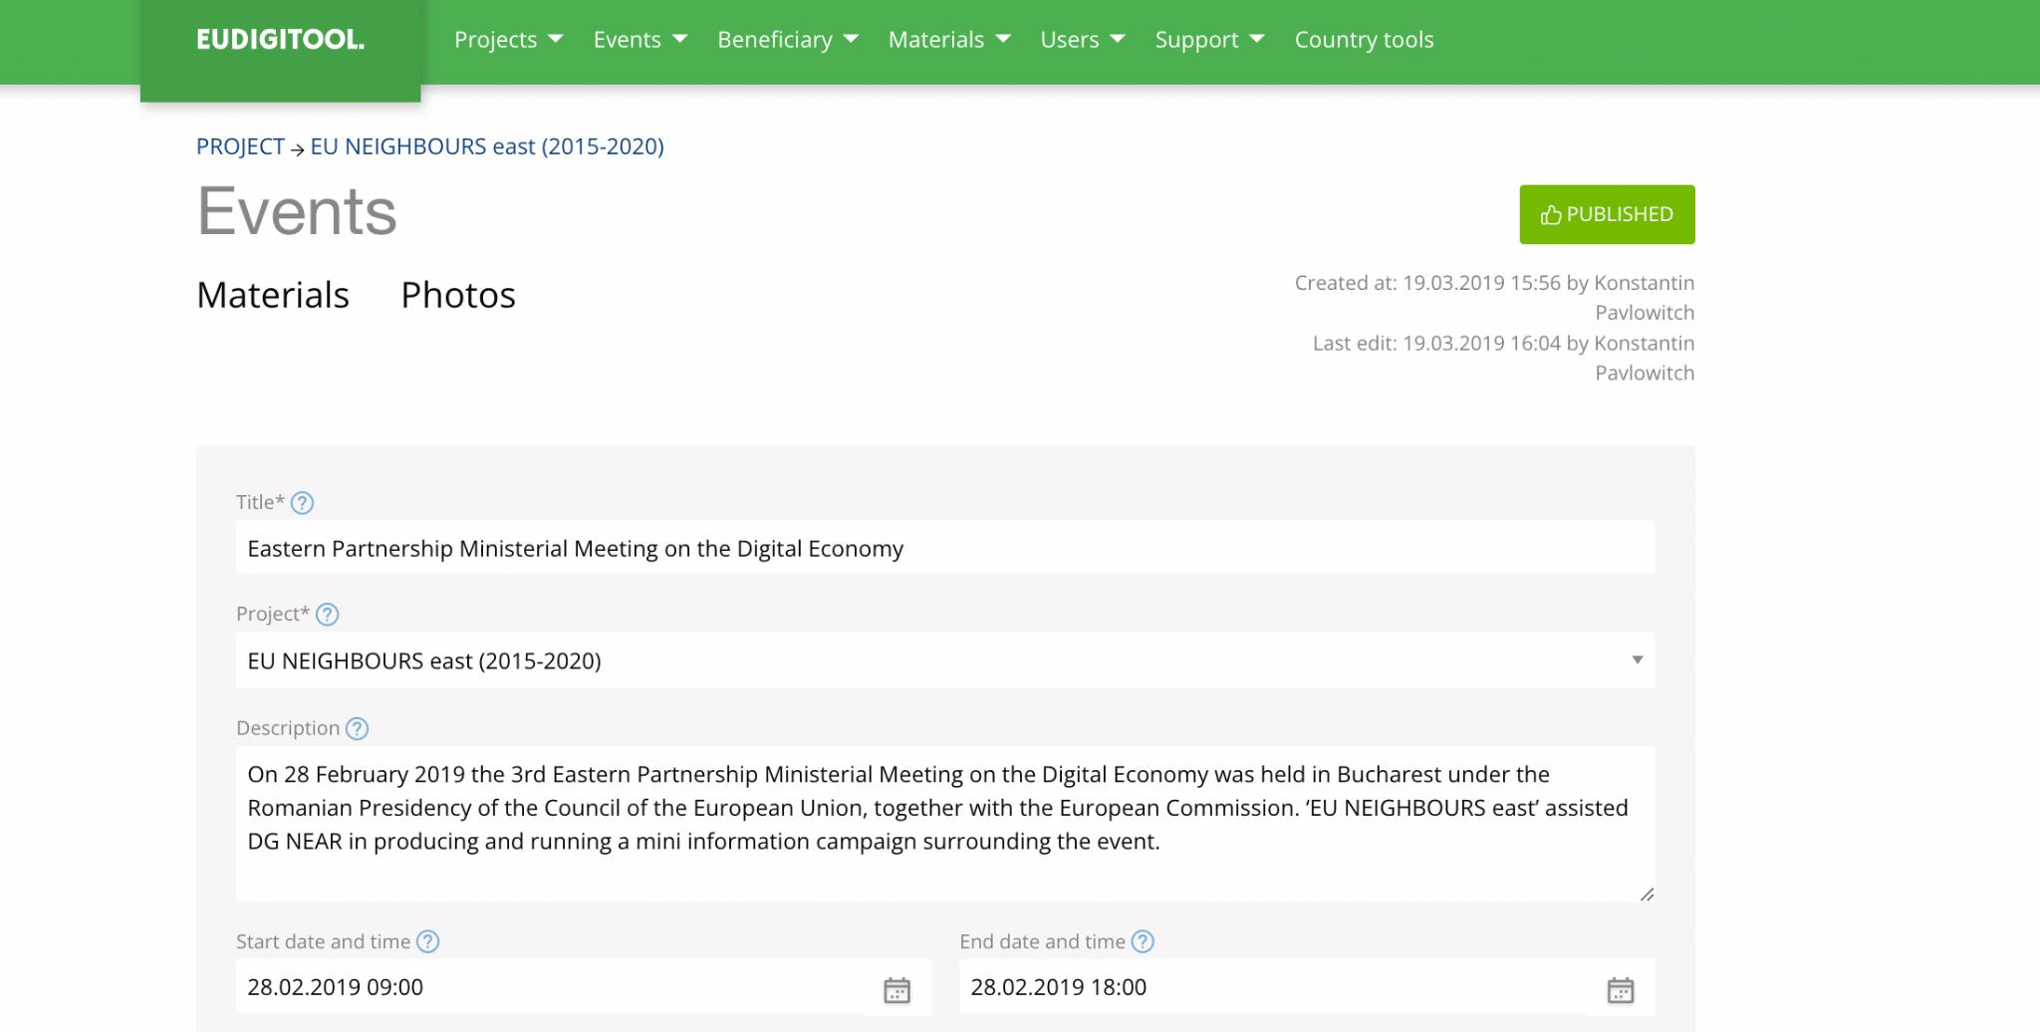

Events’ Photo Gallery

NB! Photos can be added only after the event has taken place, please do not forget to do so.

The photos should:
- be of high-resolution quality.
- be organised in an album per event.
- have captions.

The albums should be properly titled and should contain captions of all photos and should be supported by Consent and Assignment of Rights Forms, as per general EU Communication and Visibility guidelines.

NB! No photos are to be uploaded if the consent form from the featured person(s) or the assignment of rights forms from the respective audio-visual specialist/produce/author are missing.

Check out more information on the Consent and Assignment of Rights form below in the ‘Photo Gallery’ section.

Beneficiary

The EU's communication is results oriented, showcasing the impact of the EU's support on daily life of people. This section is intended for information about beneficiaries that received support from the EU through your programme/project.

Title of the Beneficiary: Insert the title of the Beneficiary in English and the local language in the relevant fields.

Description: Provide brief information about the Beneficiary, the latter’s activities and goals achieved with the support of the European Union.

Type of beneficiary: Select the type of Beneficiary from the list. If the list does not reflect the type of the Beneficiary you wish to highlight, please contact the ADMIN/SUPERADMIN and they will address your needs.

Region: Select the region from the list.

Location of the activity, beneficiary or the results: Enter the address and select the exact location from the list. If the address doesn't appear automatically, drop the pin manually on the location in the map. Click + to add more.

Amount of the EU funding in EUR (if known and relevant).

Contact information of people benefiting from the activity: The contact information is required in case the story is featured in the EU's communication materials, in order to be able to contact the featured person(s) for further information and consent, if relevant.

Communication materials: To add communication materials, click ‘Add new’.

You can add information about as many Beneficiaries as your project has from the Project profile by using the button ‘Add new’ next to the Beneficiaries’ section in the Project profile.

You can also mark Beneficiaries, Events and communication material as ‘Featured Item’, and it will appear at the top of your list.

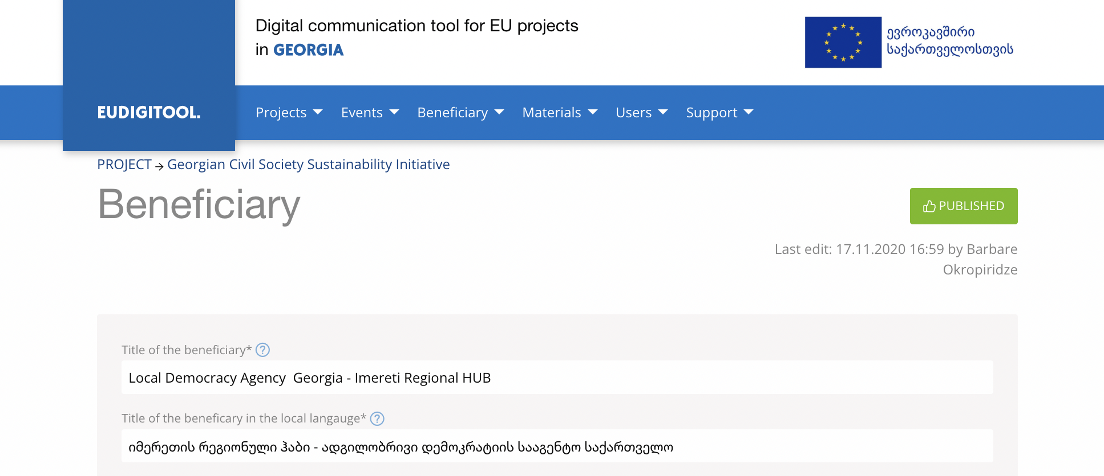

Posts

This feature is used for creating a story or blog content about your project’s tangible results and achievements. The main purpose is to illustrate the positive impact that the EU support has on the daily lives of citizens.

You may create posts whenever your project has tangible results or achievements to communicate to the general public.

For creating a post, click ‘Add new’, draft the post and save. Similar to other communication items the posts need to pass the approval workflow before being approved and published.

The post will be published in the standard WordPress post format, which is search engine friendly and can be easily found via Google and other similar platforms.

The approved post will be published on your project page on the euneighbourseast.eu and EU4Country.eu websites by default.

If it’s attractive for other target groups as well, the websites’ Editors may choose to promote your post also on other sections of the websites. However, it should be noted that this cannot be considered a must.

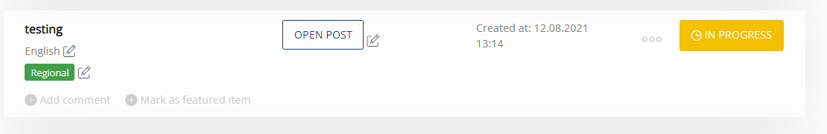

Videos

Users can upload videos directly to the EUDIGITOOL. Videos could also be published on your project profile on the websites interlined with the EUDIGITOOL.

Under the video settings, the user can also pick embedded video code to show the video on other websites, similar to YouTube function etc.

All the uploaded videos must pass the standard approval workflow mentioned above.

Please select the relevant language and country by clicking the edit button (pen icon) on the left-hand side under the title. The approval procedure is similar to what was described in the ‘Communication materials’ section.

It is possible to replace the video by clicking the edit button (pen icon) under the video and selecting the option ‘Upload New Video’ on the top-right corner as shown in the screenshot below.

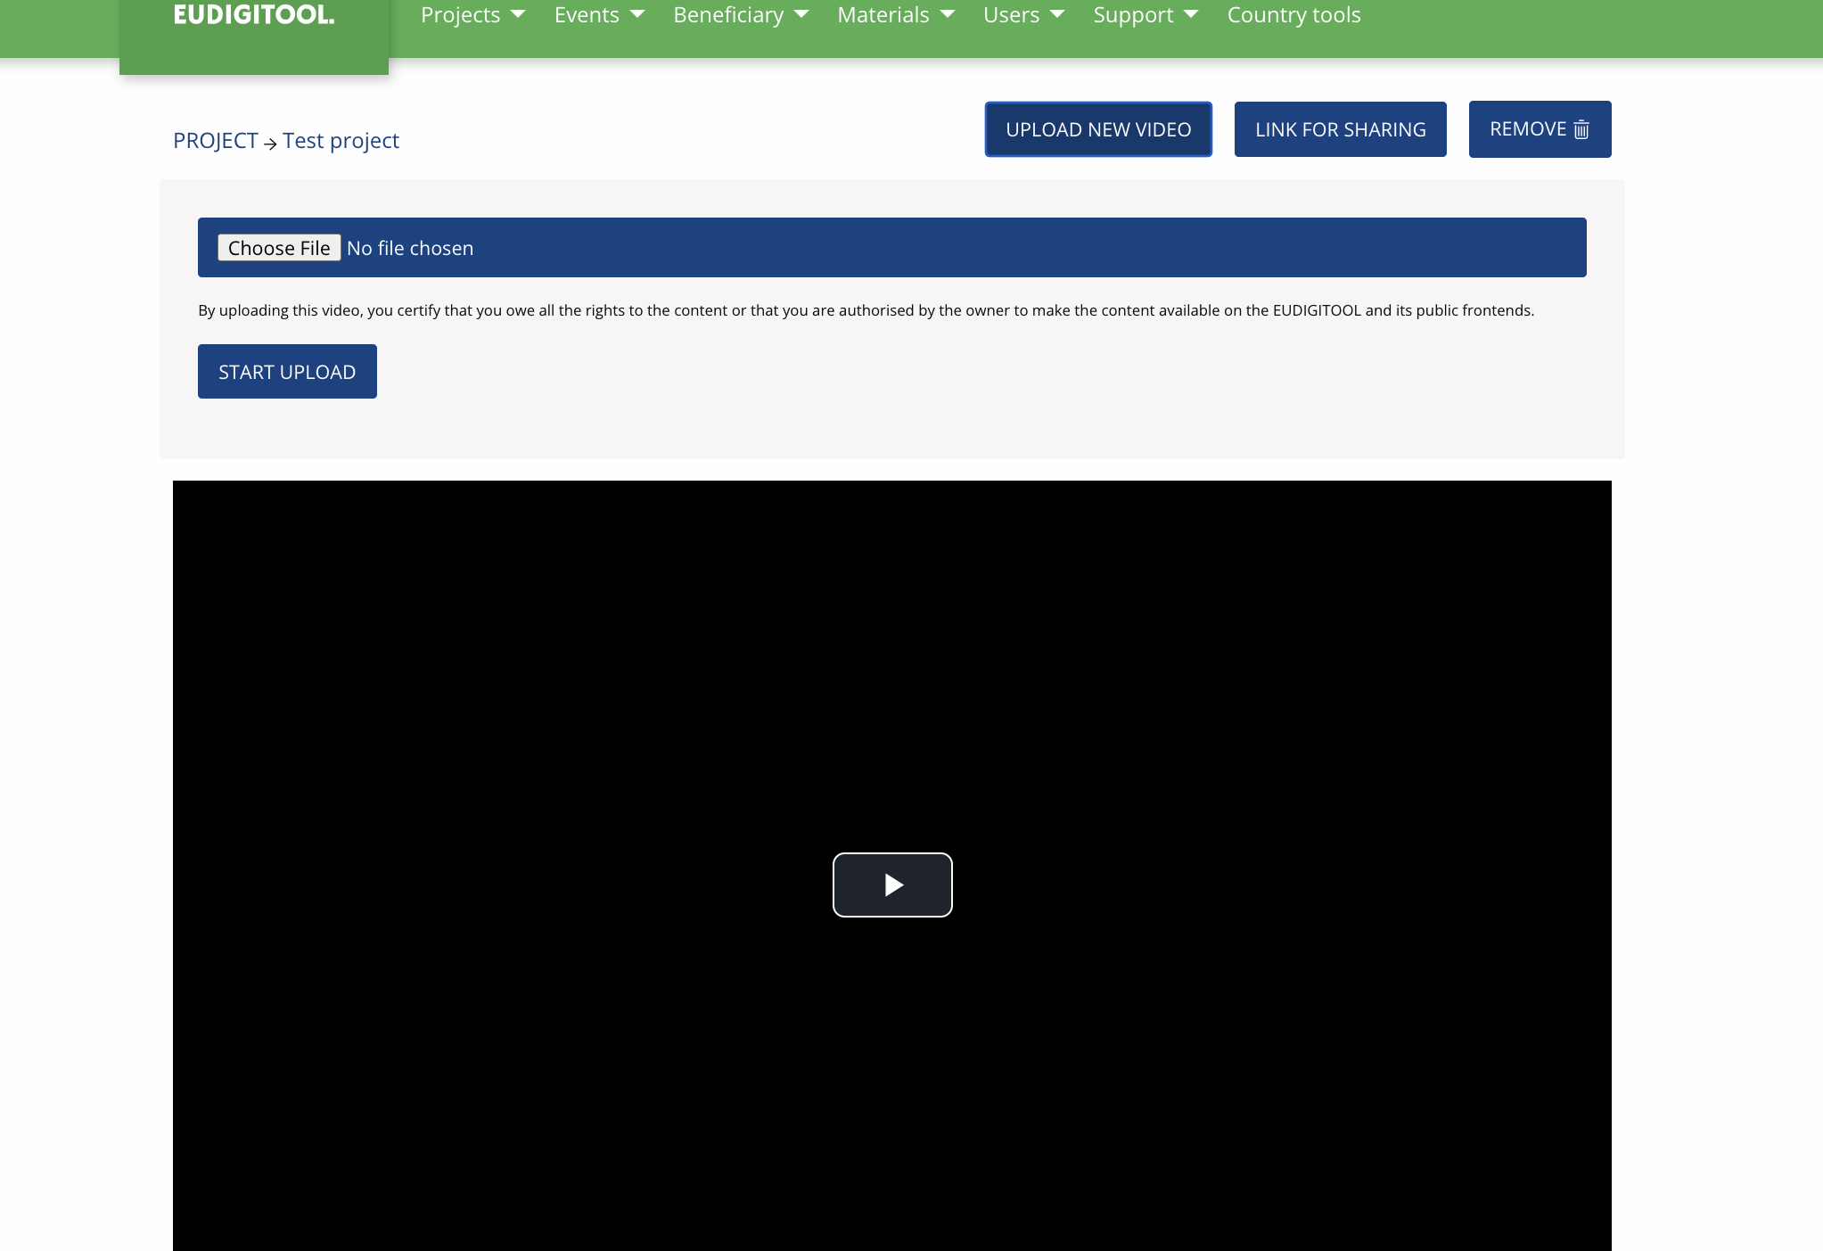

You can control which videos go public by ticking the ‘Publish on websites’ box.
NB! Video upload and conversion can take time, please perform action when connected to broadband.

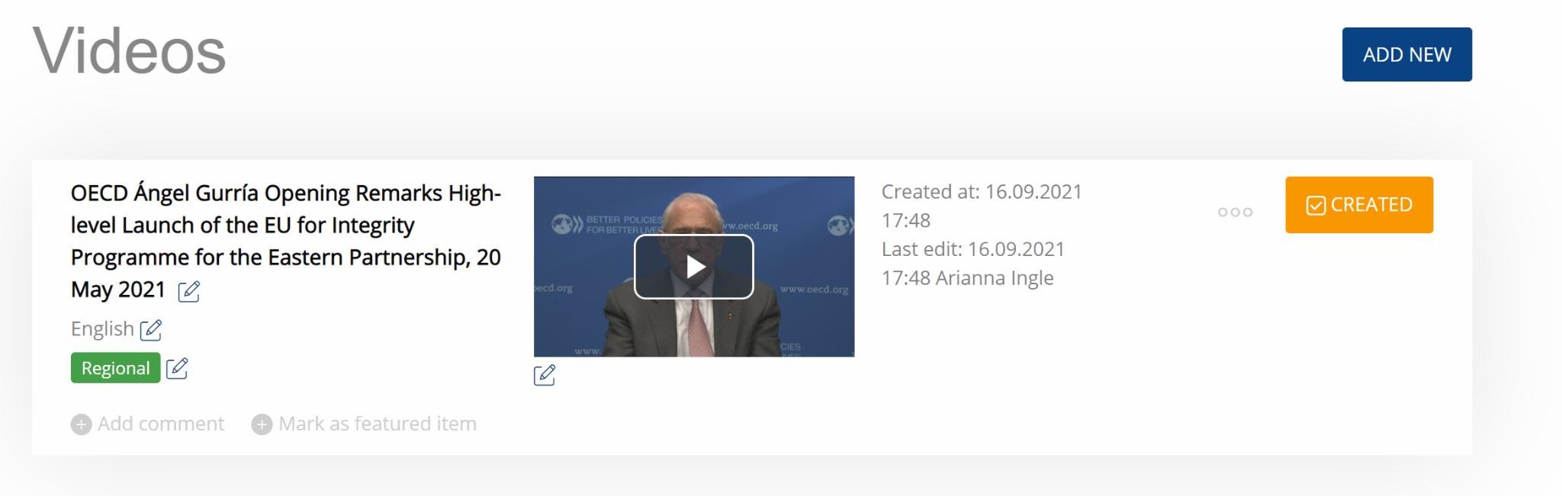

NB! It is mandatory to upload the signed Consent Form of the people shown in the video, as well as the Assignment of Rights Form.

Click the edit button (pen icon) found under video for more options and upload the forms in the respective fields.

The latest templates of Consent and the Assignment of Rights forms can be downloaded from the ‘Support’ section of the EUDIGITOOL.

Note that you can also use the Consent and the Assignment of Rights Forms provided by the EU Delegations.

Photos
You can upload photos in the Project profile, as well as Events and Beneficiaries sub-pages. The Project profile will aggregate all content of the Photos from all sub-pages.

NB! The size of the photo should not exceed 10Mb and the caption should not exceed 500 characters.

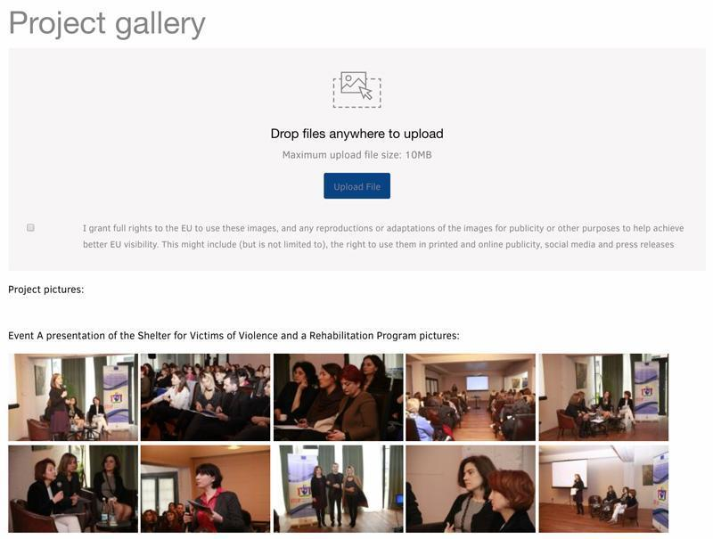

In order to save the photo and photo-related information, please press the ‘SAVE’ button at the top right-hand corner (on the blue background), which will show up as soon as you add a new photo or photo-related data.

NB! Please make sure you save the data otherwise it will be lost.

It is mandatory to upload the signed Consent Form for close captions of people, as well as the Assignment of Rights Form.

Click the edit button (pen icon) found under photo for more options and upload the forms.

The latest templates of Consent and the Assignment of Rights forms can be downloaded from the ‘Support’ section of the EUDIGITOOL.

Note that you can also use the Consent and the Assignment of Rights Forms provided by the EU Delegations.
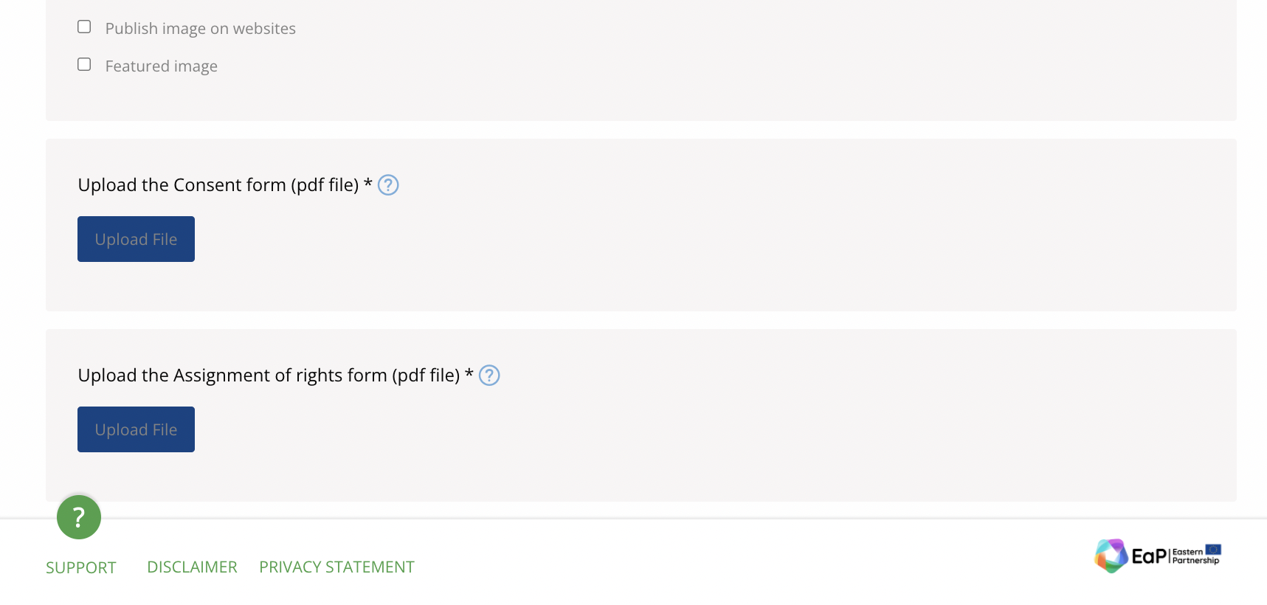

The photos uploaded in the Project profile may be displayed in your project page on the aforementioned EU DIGITOOL public frontends.

In order to publish a photo, click the edit button (pen icon) under the photo and tick the box ‘Publish image on websites’. If you want the picture to also become the cover photo of your project page on the websites, tick the box ‘Featured image’. You can create a Photo Gallery in your project page.

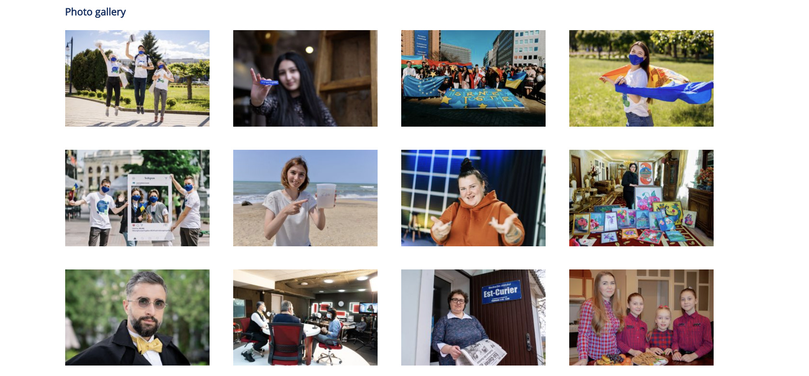

Translation of Content

Each Project profile, as well as the sub-pages of Events and Beneficiaries comprise local language section(s) for inserting translations in local language(s) of the information which has been quality-assured and approved in the English language section.

In the Regional Project profiles the relevant local language tabs automatically appear as soon as you add the EaP countries where the project is being implemented in.

The system also allows you to add additional language tabs manually, by clicking ‘+’ tab.

The number on each tab shows the amount of incomplete mandatory fields.

The goal is to get all 0-s on each tab, which means that all the required fields for translations have been completed.

There are grey inactive fields in the local language tabs, which are being automatically completed with translations by the system. It also indicates that those fields can be edited only in the English language section.

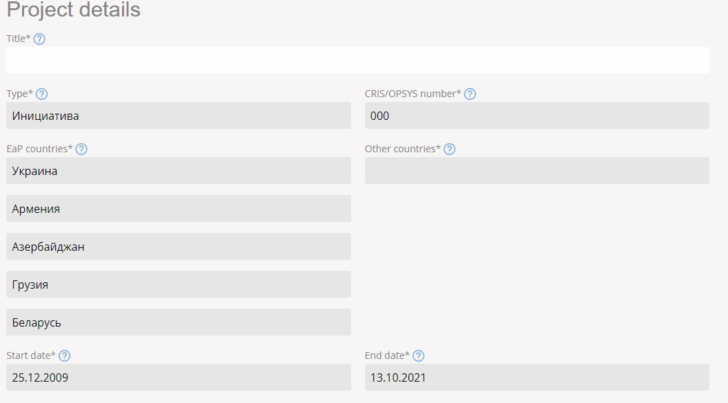

Automatic generation of project info sheet

Due to this function the key information is being automatically extracted from the Project page and exported in an A4 PDF Factsheet. To ensure that your project’s Factsheet is of good quality, make certain that all the data in the relevant fields of your project page are duly completed and the texts are kept within the required limits mentioned in the annotations of those fields in the EUDIGITOOL. The Factsheet is now available in English and local languages.

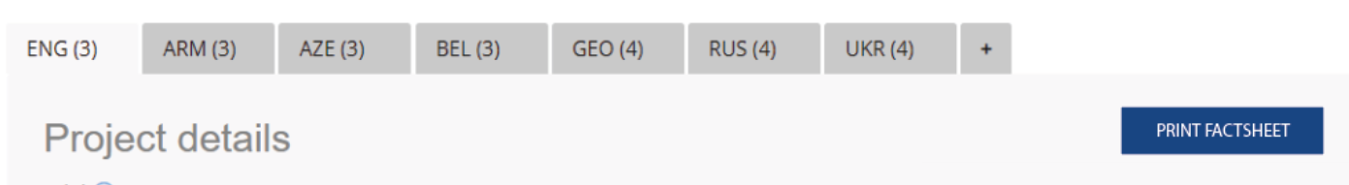

How to Search for a Project in the EUDIGITOOL?

To search for a project, go to the ‘Projects’ menu (at the top) and select ‘All Projects’ in the sub-menu.

The users can search for published regional and local (both ongoing and completed) projects in all the branches of the EUDIGITOOL by different criteria: project title, CRIS/OPSYS number, tagwords, country, project’s status, regional umbrella, priority area, subsector, budget, start/end dates and implementing organisation.

In order to search for a project by its full title quotation marks (inverted commas) must be used, which signal the system that the user is looking for an exact match. Searching within quotes will only find results that include all of the words in the title, in that specific order. Searching without quotation marks, as a result will bring all the projects that comprise any of those words in their titles as well.

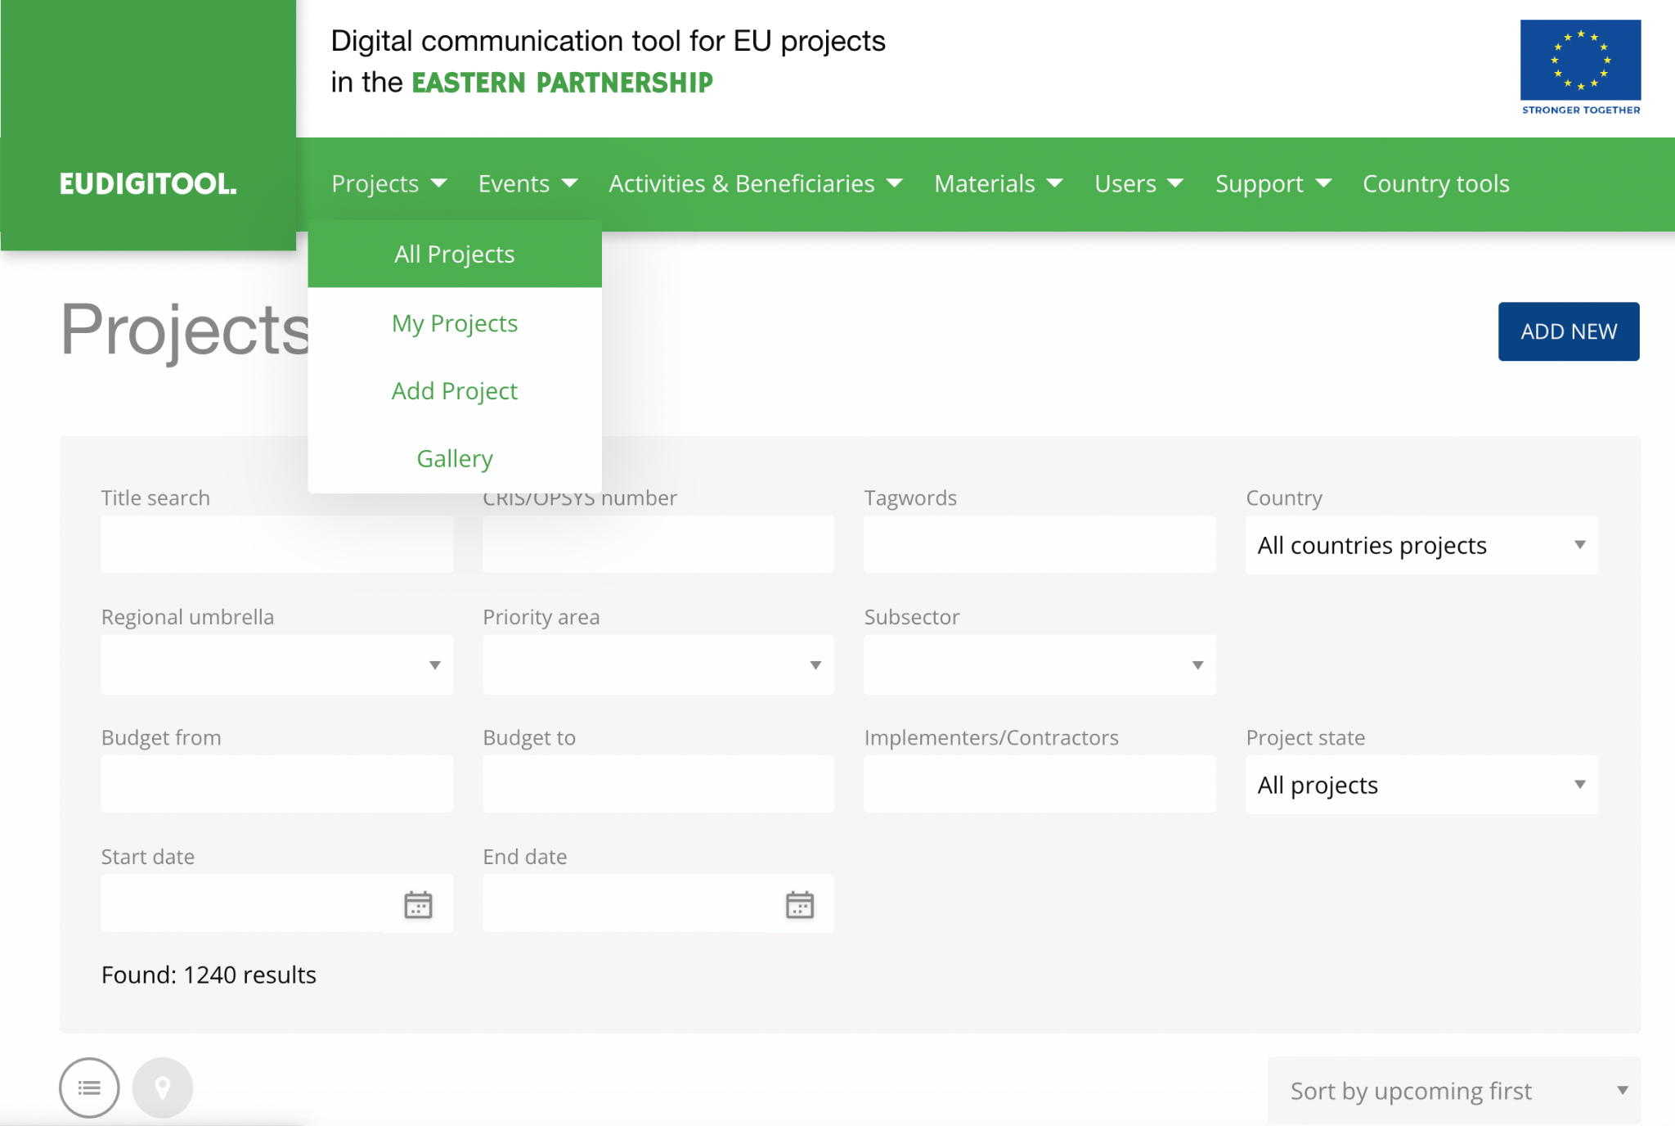

EUDIGITOOL Support Portal
The users can already create queries and report about the issues they face in the system by simply clicking the ‘Support’ button found on the right-hand side of each section of the tool and submitting the filled-out form.

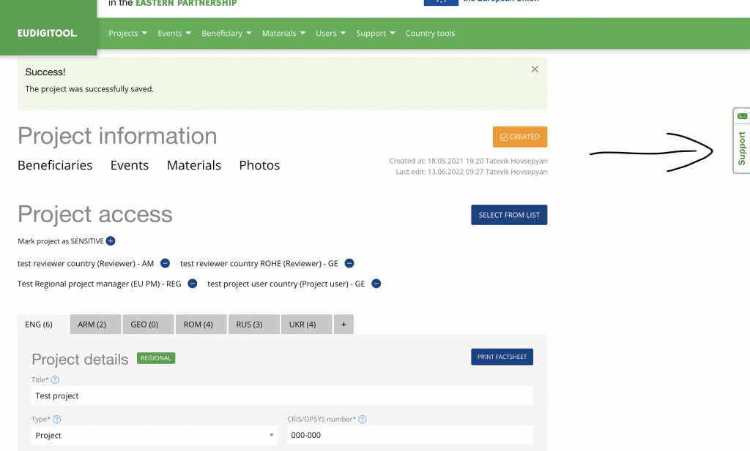

The EUDIGITOOL Support Team will reply to the queries and address the technical issues as soon as possible keeping you posted regularly on the status of the submitted tickets.

The most frequently asked questions by the Users will be included in the FAQ section of the Support Portal, giving the Users the opportunity to get answers to their questions online by simply typing the keywords in the respective search field.

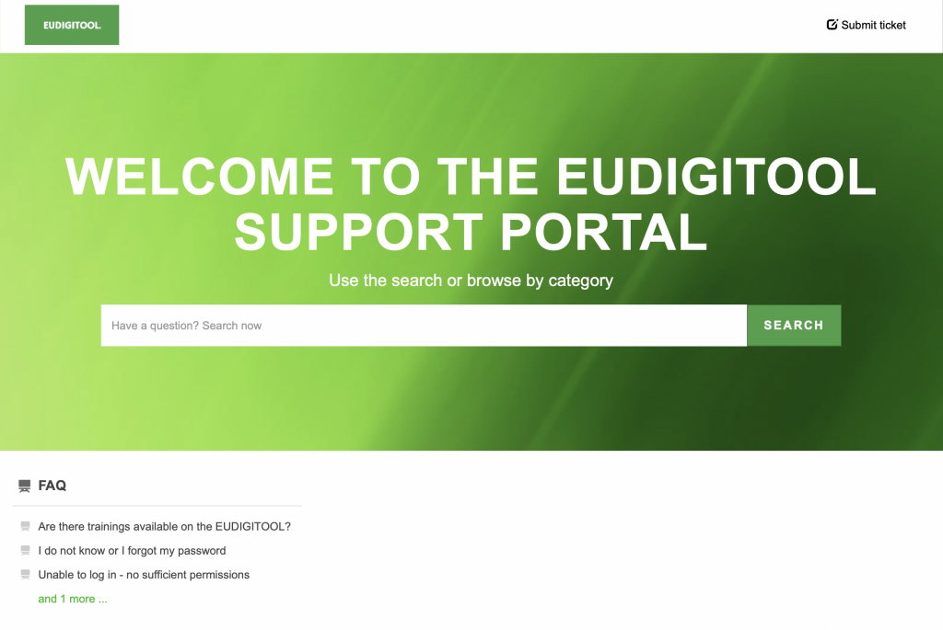

You can access the FAQ page by clicking the question mark symbol found on the bottom of each EUDIGITOOL section.

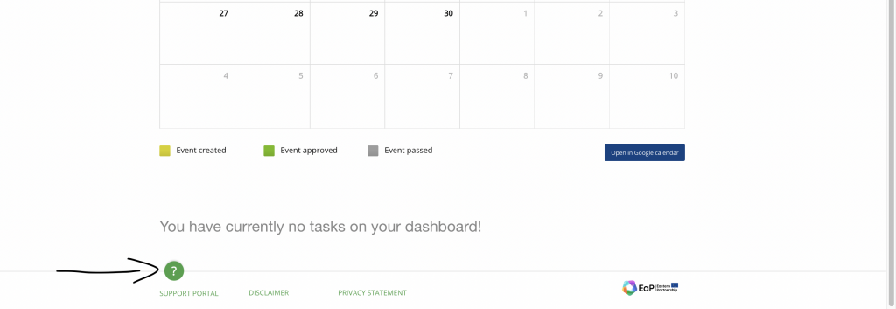

Questions and Answers

Q: I do not remember my password?

A: Please try to log in with the last password you remember. If not successful, a password recovery link will appear:
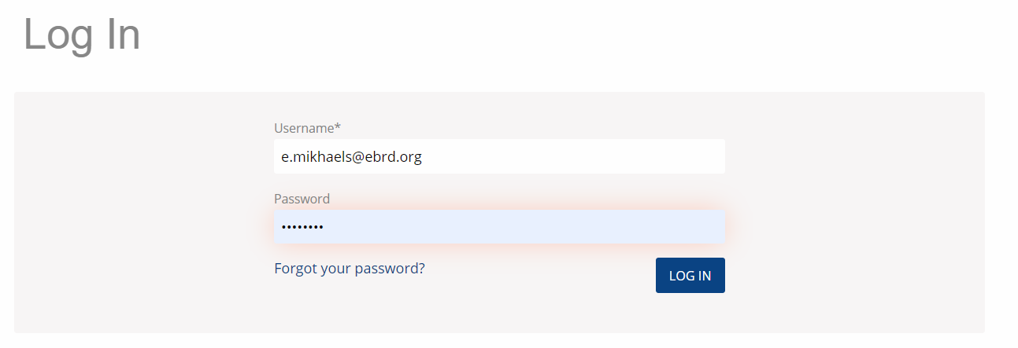
If you click on the ‘Forgot your password’ link, the EUDIGITOOL will send you the password recovery link to your registered e-mail address. The password recovery link is valid for up to 1 hour.

Q: I do not remember my e-mail address that I am registered with?

A: This is usually your work e-mail address. Please check you e-mails that you have access to. If you see notifications from the EUDIGITOOL previously, this might be the right e-mail address. If that does not help, please contact your ADMIN/SUPERADMIN to get your user details.

Q: I can’t find my project?

A: Please take a look at: Project menu > My Projects. Projects assigned to you should appear there. If this does not help, please contact the ADMIN/SUPERADMIN to get your user details.

Q: I have a different problem or system seems not working?

A: Please use ‘Support menu’> Contact form to report your problem. The EUDIGITOOL support team will reply to you via e-mail.

